- Add custom url in cognito user pool
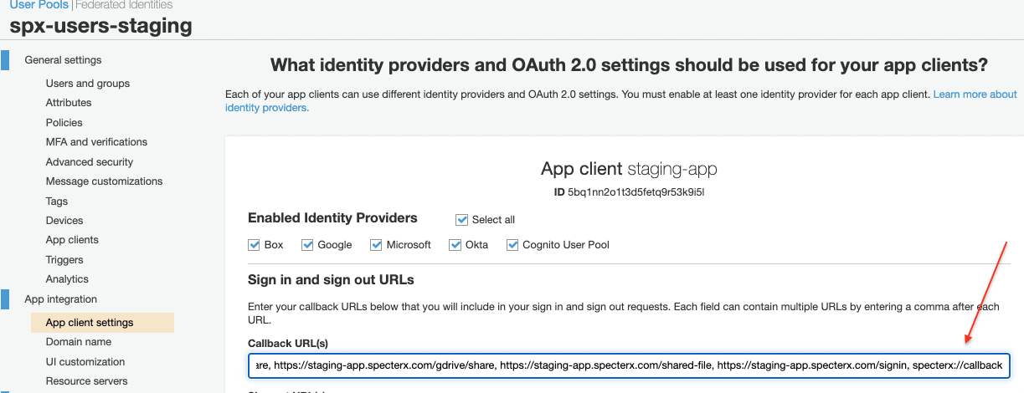-

Unzip custom-uri-handler.zip on computer with proxy configuration.
https://drive.google.com/file/d/1DCSoIkyRP1thNBlRsc8pJ1GINRCcqMF6/view?usp=sharing

Run file from cmd and press any key to register the handler.
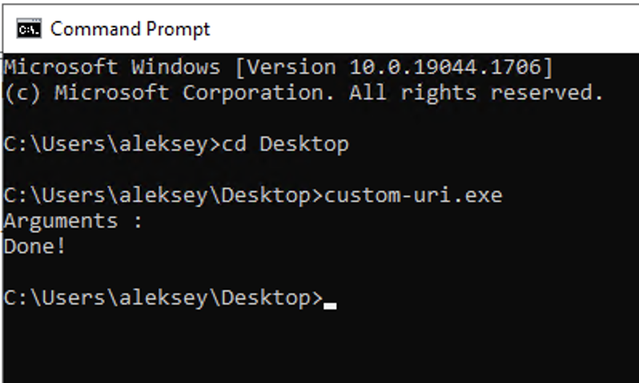

Copy url and choose microsoft from the given options and login with microsoft account.
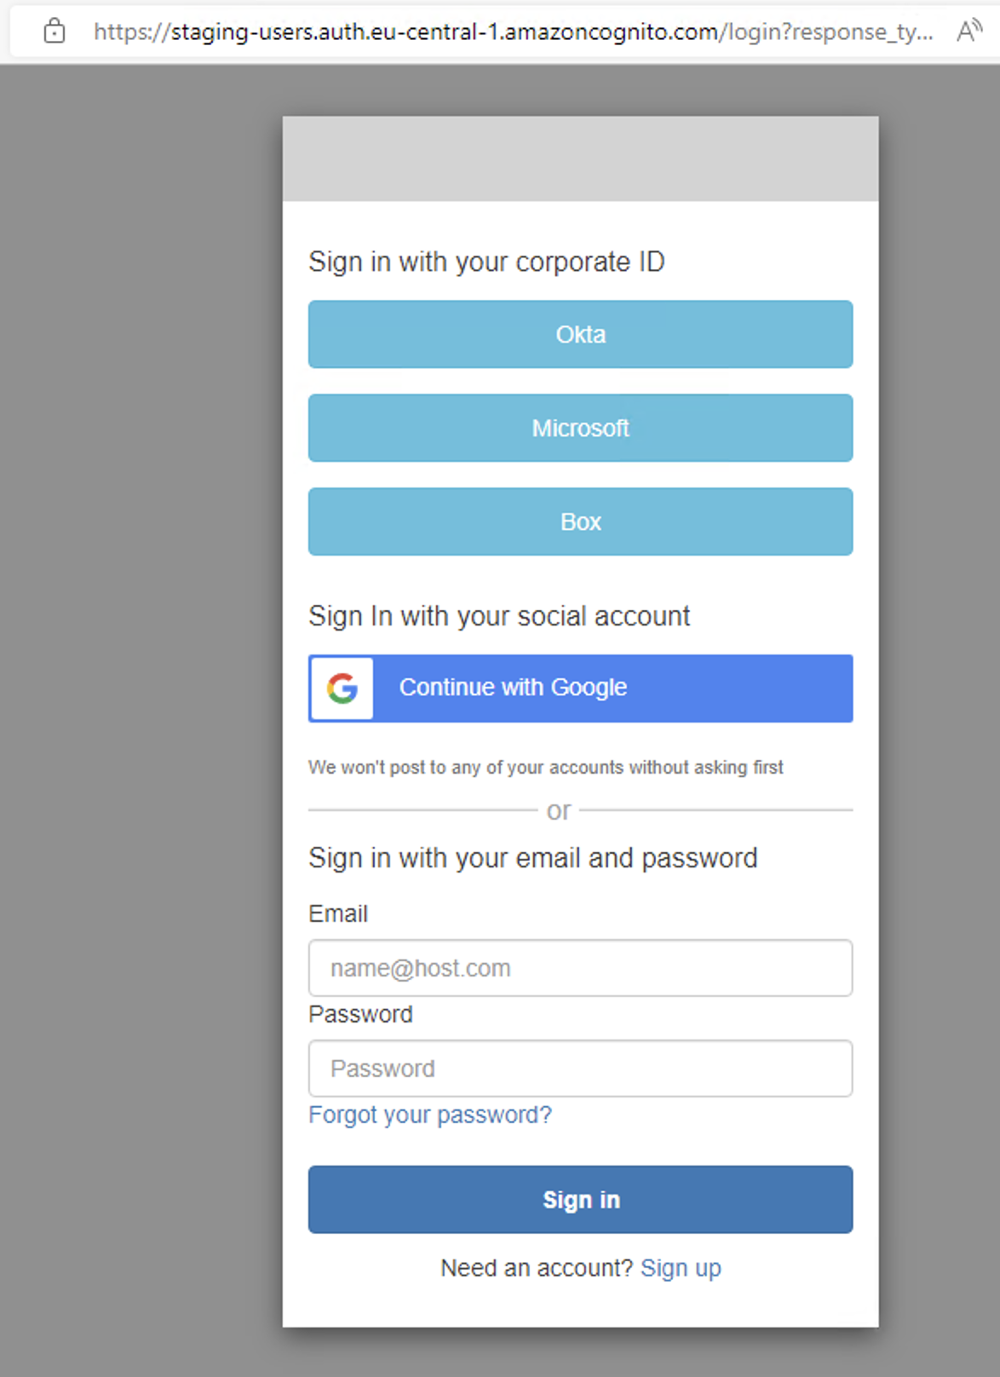
Example for staging-users:
https://staging-users.auth.eu-central-1.amazoncognito.com/login?response_type=code&client_id=5bq1nn2o1t3d5fetq9r53k9i5l&redirect_uri=specterx://callback
Example for shikunbinui-users:
https://shikunbinui-users.auth.eu-central-1.amazoncognito.com/login?response_type=code&client_id=20gibjfm5kaue16nli932q9b5u&redirect_uri=specterx://callback

Aftrer successful login pop-up window will show up, press Open.
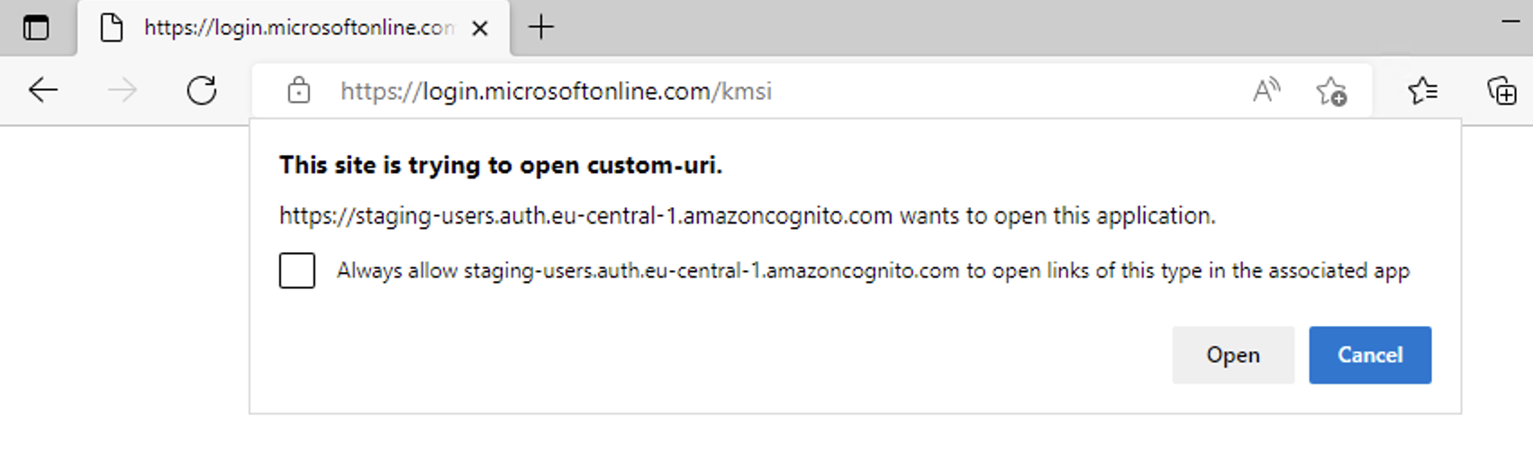

Custom-uri will popup will show up.
